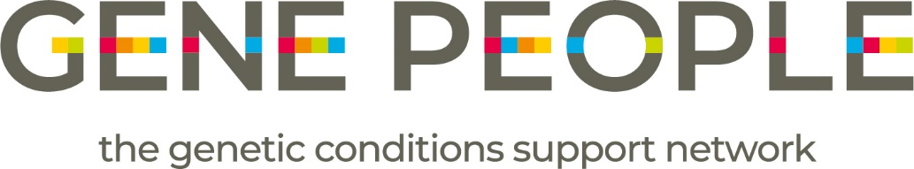
Gene People Ethnic Diversity and Racism Statement
Gene People is a charity that improves the lives of those affected by genetic conditions and their families, carers, and support network, and supports condition-specific support groups. We want anyone impacted by genetic conditions to get the treatment, care, information, and support that they need and want.
We are clear: racism is not tolerated in Gene People in any form.
We are fully aware that racism plays a part in health inequalities, adversely affecting people from marginalised communities. We are committed to taking steps to challenge racism in our work and the genetic conditions sector. Our first step in contributing to tackling racism is our membership of the Breaking Down the Barriers network.
We want Gene People to be an organisation in which everyone feels valued, whether they are a person using our services, a team member, a volunteer, an external colleague, or supporter.
Gene People is an anti-racist organisation and will:
- Improve representation of marginalised groups at all levels of our organisation
- Review our systems, processes and services to ensure we are not perpetuating racism or creating barriers to participation
- Include equality, diversity, inclusion and anti-racist practices in Gene People’s recruitment processes
- Challenge racism where we see it and support people who have experienced racism by providing a safe space for them to raise their concerns
- Encourage members of our Partnership Network to join the Breaking Down Barriers network and acknowledge their responsibility in challenging racism
- Seek funding to be able to fulfil and expand our anti-racism activities.
Through these actions, Gene People will contribute to creating a fairer and more equitable society for those affected by genetic conditions.

