Genetic Disorders UK genetic counsellor-led helpline: A service evaluation

Ella Kershaw University of Exeter

September 2020

Contents
Abstract. 4
Introduction 5
Methods 6
Results: Surveys 10
Results: Interviews 12
Positive impressions of the genetic counsellor 13
Contact can make a difference to enquirers 15
Simple contacting process 16
Lack of information 16
Finding GDUK online. 17
Satisfaction with response time. 18
Feeling supported 18
Challenges of a genetic disorder 19
Discussion 20
Conclusions 22
References 23

Figures and tables

Figure 1. Post-contact survey questions 7

Table 1. Questions asked of participants in telephone interviews 8

Table 2. The six phases of thematic analysis 9

Table 3. Demographics from pre-contact surveys 10

Figure 2. Graphs of results from the electronic surveys 11

Table 4. Responses to the final three post-contact questions 11

Table 5. Excerpts from comments written in the post-contact survey 12

Table 6. Summary of interview participants 13

Quotations 1. Positive impressions of the genetic counsellor 14

Table 7. Sentiments ascribed to the helpline genetic counsellor 15

Quotations 2. Contact can make a difference to enquirers 16

Quotations 3. Lack of information 17

Quotations 4. Lack of awareness of GDUK. 17

Quotations 5. Satisfaction with response time. 18

Quotations 6. Feeling supported 19

Quotations 7. Challenges of a genetic disorder 20

Abstract

Genetic Disorders UK (GDUK) is a registered charity that provides a free genetic counsellor- led helpline, which can be contacted by anyone. A service evaluation was conducted to assess how well GDUK was performing. Online surveys and telephone interviews were used to collect data from helpline enquirers in a mixed methods approach. The surveys were in two parts, pre-contact and post-contact, to allow comparison of enquirers’ responses. Qualitative data were analysed using thematic analysis, with themes including lack of awareness of GDUK in the NHS, looking to talk to others, and satisfaction with response time. Overall, enquirers reported feeling supported and helped by GDUK, and said that they felt the genetic counsellor understood them. People also reported feeling less anxious and confused following contact with GDUK. One suggestion was that GDUK should raise awareness of itself, particularly within the NHS, so that healthcare staff can recommend the helpline to individuals that may benefit from it. Both surveys and interviews showed similar positive results, with the majority of enquirers saying they would recommend GDUK or contact again.

Introduction

In the UK there are estimated to be around 3 million people affected by a genetic disorder^{[1]} and approximately 300 genetic counsellors^{[2][3]}. With public awareness of genetic disorders increasing, there is greater need for those who can offer advice and support for those affected.
Genetic Disorders UK (GDUK) is a registered charity, established in 2011^{[4]}, with the aim of providing information and support to those affected by a genetic disorder^{[5]}. Along with organising events to raise awareness of genetic disorders, such as Jeans for Genes, GDUK also offers a helpline^{[6]} led by a genetic counsellor (GC), though it is not a genetic counselling service. GDUK aims to respond to all enquirers within 3 working days^{[6]}.
Crucially, this helpline is not only accessed by those directly affected, but also by relatives, friends or healthcare staff working with affected individuals. A genetic diagnosis not only affects the individual, but also the individual’s family, which can be stressful for all involved^{[7]}. Anyone affected, whether directly or indirectly, is able to phone GDUK to talk to the GC about the condition and their concerns.
Most genetic counselling occurs through the NHS, requiring referral by a GP or other primary care provider^{[8]}. A telephone helpline operating outside the NHS allows anyone from anywhere in the UK to get in contact should they feel they need it, without needing to go through their GP or pay to see a private GC.
A study looking into telephone interviews as a research technique found them to be as effective as face-to-face interviews, with participants feeling less judged and more able to focus on the interviewer’s voice^{[9]}. It seems reasonable that this could apply to telephone genetic counselling, with enquirers potentially feeling less self-conscious whilst talking about personal issues and being able to focus on the GC and what they’re saying. The helpline also allows enquirers to contact at their own pace, as not being ready to hear the information may be another barrier to the effectiveness of genetic counselling^{[10]}.
GDUK has been running the helpline for 5 years^{[11]}, and this is the first service evaluation conducted. A service evaluation aims to review a service to see how well it is performing compared to its objectives^{[12]}, and is becoming more common in healthcare environments^{[13]}.

In this case, the aim was to gain an objective understanding of users’ thoughts on GDUK’s helpline service, and to see how well GDUK is performing and if there are improvements that could be put in place. This was a formative evaluation, as it was assessing the service whilst it is active^{[14]}. The three main objectives of this project were to assess the satisfaction level of users, see how anxiety levels changed following contact, and assess how supported users felt by GDUK. The level of satisfaction was based on several factors, such as satisfaction with GDUK’s response time and their thoughts on the GC with whom they spoke.

Methods

Electronic surveys and telephone interviews were used together in a mixed methods approach. This particular approach used the convergence model of triangulation design^{[15]}, meaning the qualitative results from the interviews were used to expand on the quantitative results from the surveys. This should result in more comprehensive insight into user satisfaction. The surveys themselves were in two parts, pre-contact and post-contact, to allow analysis of any changes in attitudes and opinions.
The University of Exeter’s Research Ethics Framework was followed for this project^{[16]}. Any questions asked in interviews were reviewed by the author with two supervisors, in line with the university’s guidance on ethical approval for service evaluations.
Surveys were sent out as soon as a person contacted GDUK, and they were asked to complete the pre-contact questionnaire in the time it took the GC to respond. Once the enquiry was resolved, a post-contact survey was sent out to assess changes in attitude after speaking to the helpline GC (figure 1). The surveys, designed by GDUK, were based on the Genomics Outcome Scale (GOS)^{[17]}, which itself is a shortened version of the Genetic Counselling Outcome Scale (GCOS)^{[18]}, and asked enquirers to what extent they agreed with the given statements. The answers were based on the Likert scale^{[19]} (Likert, 1932), featuring five steps, from strongly agree to strongly disagree. The pre-contact survey included a demographics section, but the post-contact survey did not, so that participants could not be identified. Four questions were asked by both surveys, with the post-contact survey asking additional questions on their experience. There was also a space at the end of the post-contact survey

for participants to write any other comments. They opened on SurveyMonkey on 29.11.19 and are still open. Data for this report were collected from SurveyMonkey on 26.07.20.
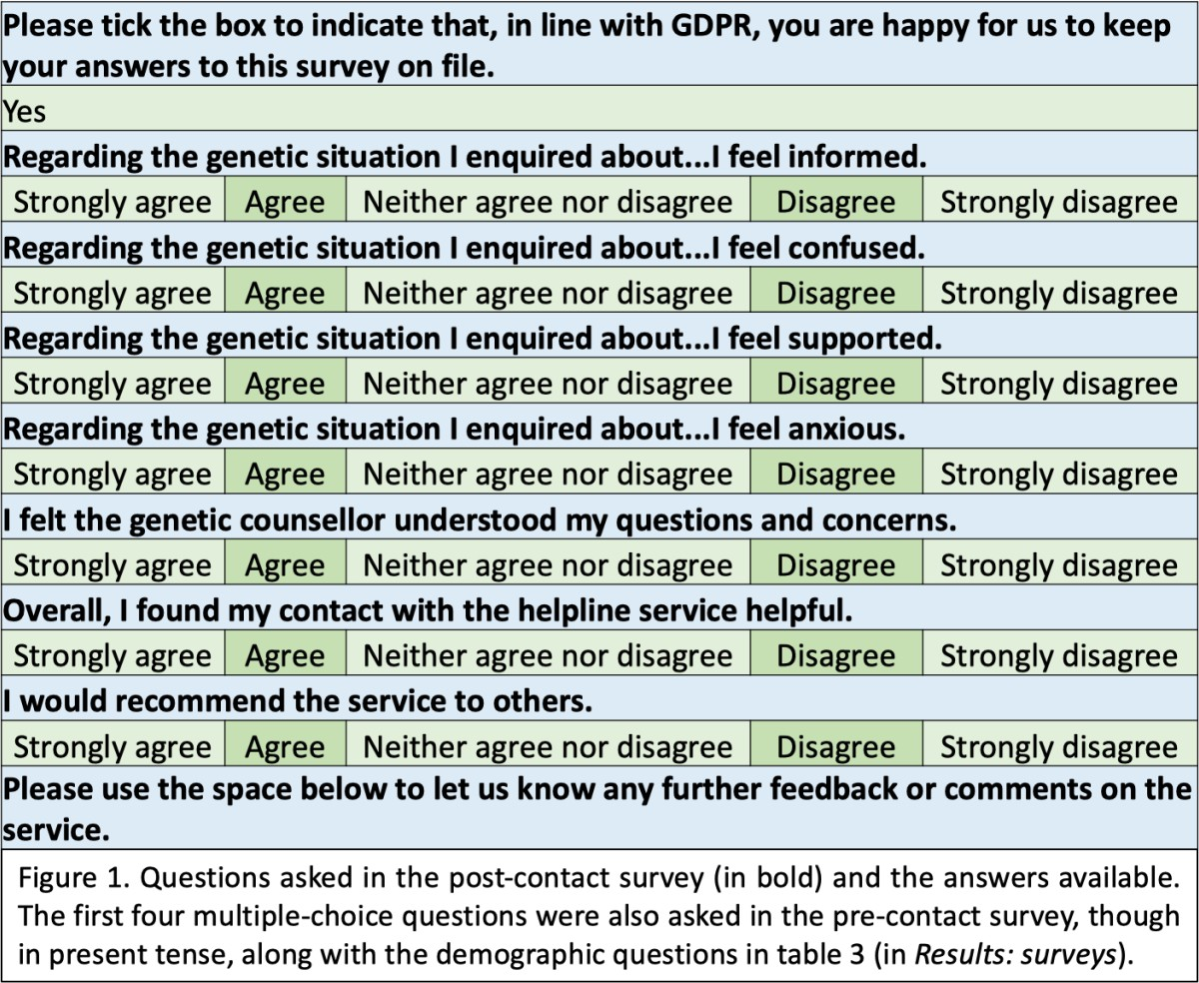

People who contacted the helpline were also invited by email to participate in a telephone interview to obtain further feedback on their experience of GDUK. Information sheets were sent to those invited, and all respondents consented to the interviews being recorded, transcribed, stored and used for analysis. All transcripts were transcribed with pseudonyms, and any identifying information was redacted.
Invitations were sent out by Emily Clarke, GDUK’s genetic counsellor, with 82 enquirers invited and 54 enquirers excluded, such as those with no contact email or those not in the UK. Those invited were sent a secondary invitation email after one month if they hadn’t replied, to encourage more responses.
The interviews were semi-structured, with questions that allowed participants to elaborate on their experience, with prompting if necessary. Question topics are listed below (table 1).

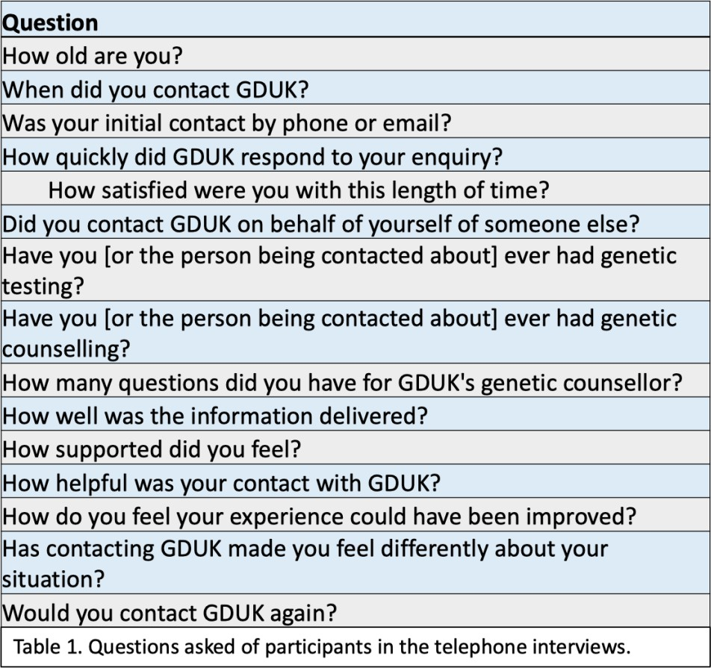

Transcripts were analysed using thematic analysis, which involved examining the transcripts for themes within them. Some were present in several transcripts and others only in one, though frequency does not necessarily make a theme more ‘important’^{[20]}. Reflexive notes were written after each interview, recording the interviewer’s thoughts, to allow reflection on the process. Major themes were discovered via a deductive analysis approach, aiming to gather data to answer the questions of the project. However, some themes were discovered via inductive analysis, meaning that the themes were formed by creating new codes that fit the data, rather than attempting to fit them into the existing coding frame^{[20]}. These tended to be themes not directly related to GDUK or the participant’s experience of it.
The analysis was carried out following the six phases of thematic analysis as laid out by Braun and Clarke^{[20]} (table 2). NVivo software was used to aid in coding the interview responses, from phase two onwards.

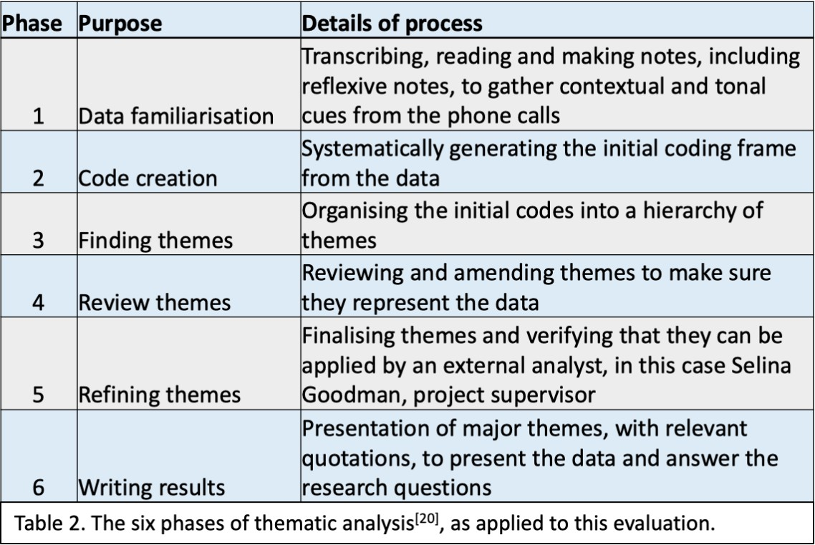

Results: surveys

A total of 18 people responded to the pre-contact survey and 32 responded to the post- contact survey. Demographics of the pre-contact survey participants are below (table 3).
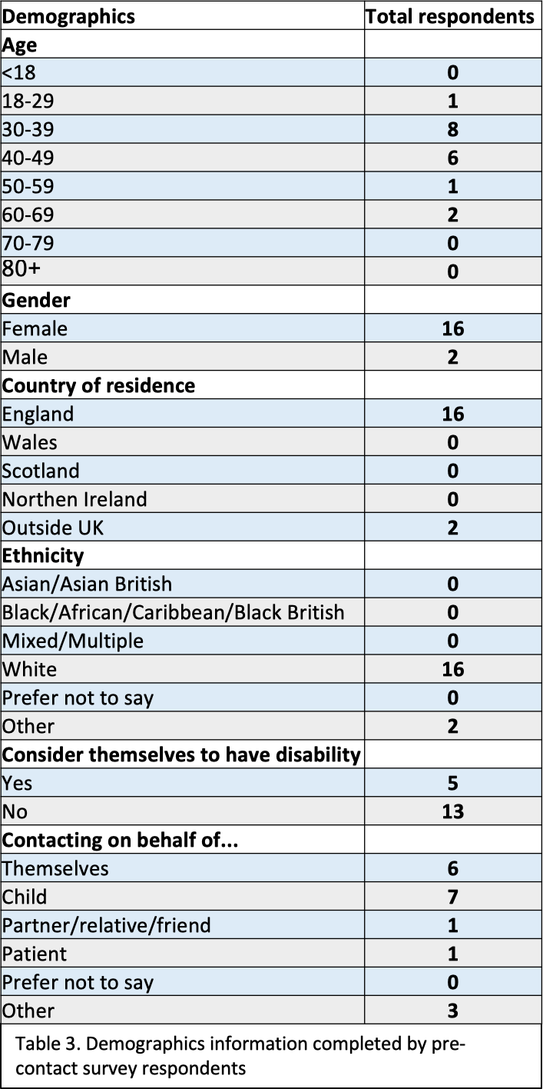

Four questions were asked by both surveys, with results showing a reduction in confusion and anxiety, and an increase in feeling supported and informed (figure 2).
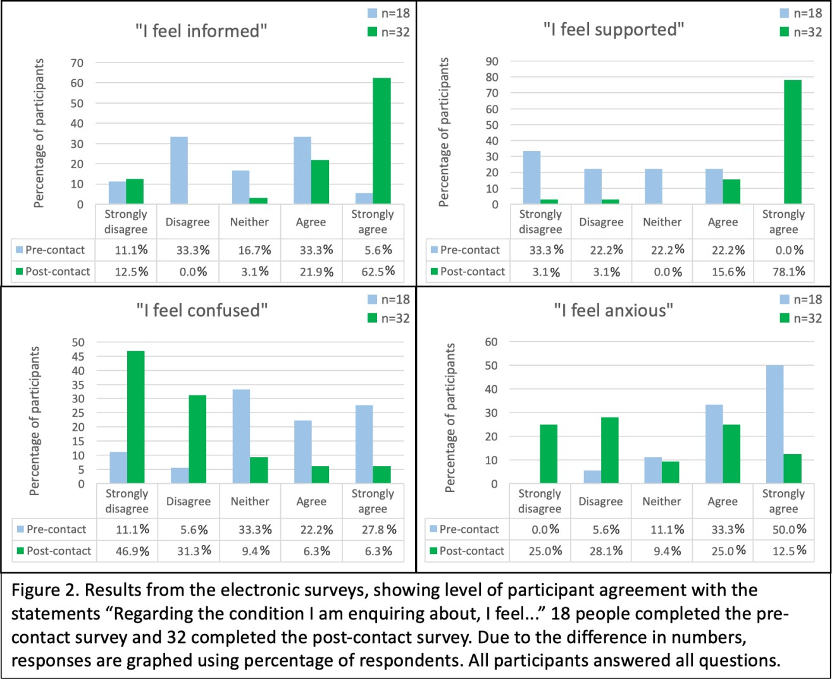

The post-contact survey asked an additional three questions regarding enquirers’
experiences, the results of which were overwhelmingly positive (table 4).
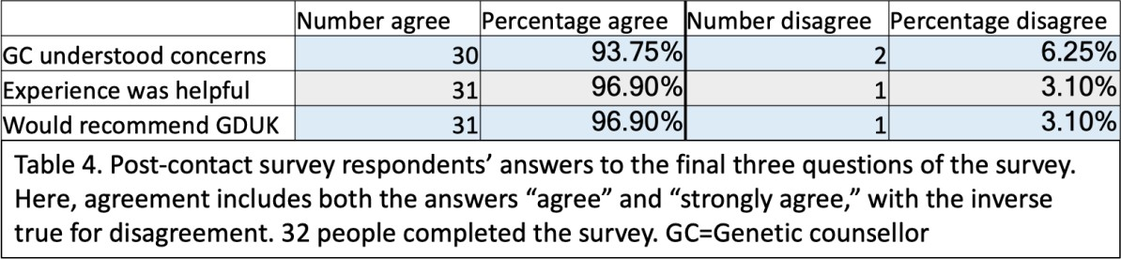

Nineteen people left additional comments in the space at the end of the post-contact survey, 18 of which were positive. The other comment said that there was “very limited information available” on the “extremely rare” condition they were enquiring about, which is likely to be due to lack of research on the condition rather than a fault of GDUK. Many of the comments specifically mentioned the GC, thanking her for her help. Excerpts from the comments are listed below (table 5).
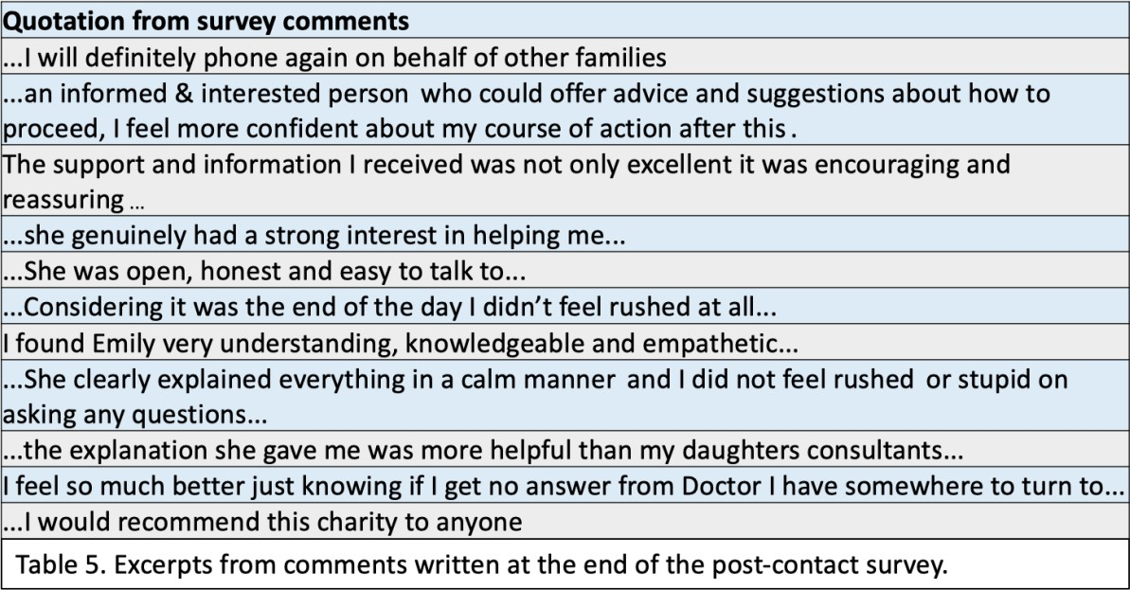

Results: interviews
Of the 82 people invited to take part in the interviews, 15 responded and participated. Two of these were married and wished to be interviewed together, but they were counted as separate respondents for this analysis. Two of the participants may have spoken to a locum genetic counsellor whilst Emily Clarke was on leave, but this is uncertain. All identifying information has been redacted and all names have been changed. A summary of the interviews is below (table 6).

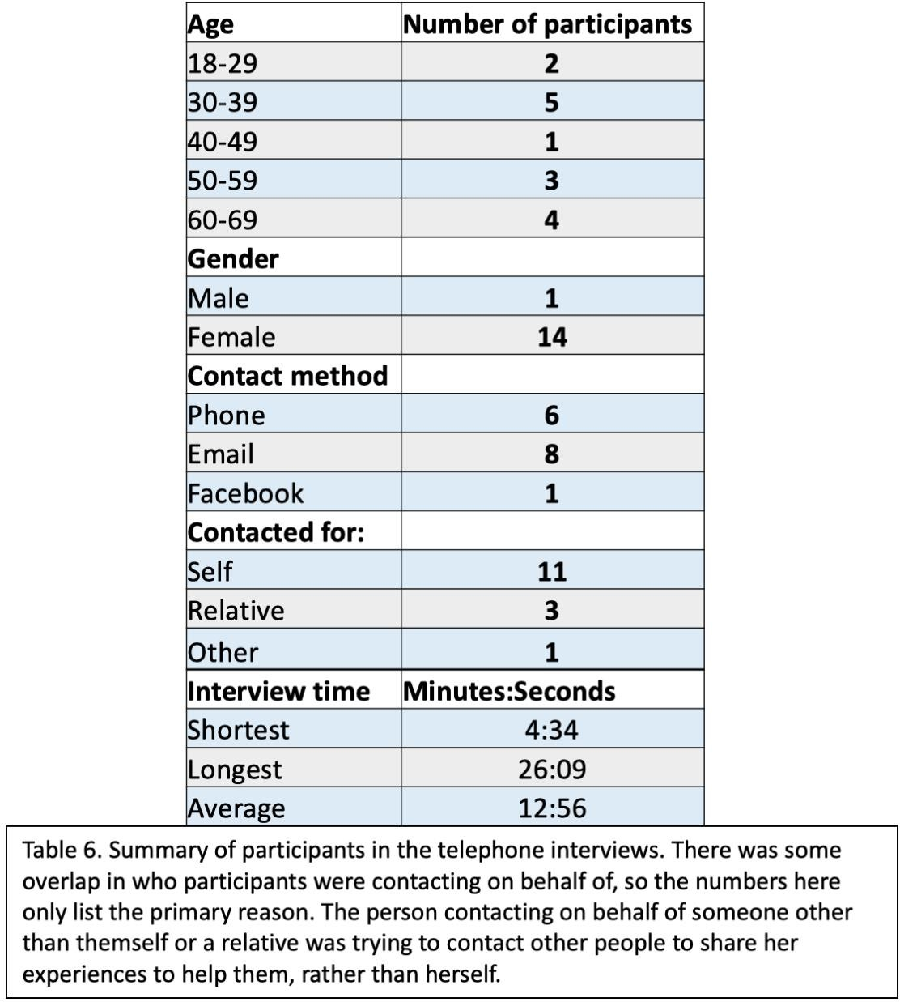

Major themes were: positive impressions of the genetic counsellor; contact can make a difference to enquirers; simple contacting process; lack of information; finding GDUK online; satisfied with response time; and feeling supported. Quotations to demonstrate each theme are enclosed in quotation figures.

Positive impressions of the genetic counsellor

A major theme was how positive an experience it was, with the GC receiving particularly favourable feedback (quotations 1) (table 7). Many people felt supported by the GC and felt she was committed to helping them. A few also said that they felt they were taking a up a lot

of time, but did not feel rushed by the GC. Enquirers appreciated any research the GC did on their behalf to be able to answer their questions.
One person contacted GDUK to get clarification on whether her son was at risk from COVID- 19 due to his genetic disorder. She felt that the GC was able to clearly answer her questions, and felt reassured following contact.

Quotation | Reference
Emily was outstanding, she really was... I felt that... I was really taking up quite a lot of her time, but, you know, she, she didn’t make me feel rushed, or anything... she went over things to make sure that I  understood everything and... she was absolutely excellent | Suzie, lines 80-83
She very kindly, er, wrote back and wished me well with that and ask, asked that I let her know how the appointment went... I think it’s  worth knowing because she... went above and beyond the call of duty | Elisa, lines 188-189,  196-197
She answered all my questions... the response was really quick and, yeah, I don’t think there’s anything that could have been improved | Rosa, lines 75-77
I just appreciate that there are people that take their time to um acknowledge you and, and support you out there... and I just really appreciate the promptness of, of her answers, so I’m really grateful,  thank you | Victoria, lines 120-122
It’s an amazing charity and I thought it was a really simple way of  speaking to somebody and she was a really lovely lady and I felt really  comfortable talking to her, and it wasn’t rushed, I’ve only got praise | Megan, lines 106-108
She could see where I was coming from and she was trying to be as helpful as possible... I could tell from her voice... she was sincere, it, it was genuine, it wasn’t kind of just oh I’m here to do a job, erm, and  you could tell that she was passionate in what she was doing | Natalie, lines 72-76
It’s very rare to get someone to actually hold their hands up and say well I’m not able to answer this, but I will find out, that, that was such, um, a very positive thing. So from my point of view I can’t think of any,  any improvement in the care I received | Holly, lines 64-67
She was extremely kind... very patient... and took on board what I had to say | Elisa, line 98
She answered [the questions] really clearly and really well | Gail, line 64
Quotations 1. Quotations showing the positive impression the genetic counsellor made on enquirers. All names given are pseudonyms.

Sentiment | No. people | Quotation | Reference
Brilliant | 1 | Emily was brilliant, absolutely brilliant | Holly, line 42
Lovely | 1 | She was a really lovely lady and I felt really comfortable talking to her | Megan, line 107
Amazing | 1 | [Lauren]: She’s been- [David]: Been very good  [Lauren]: -amazing really, | Lauren/David, line 203
Marvellous | 1 | She has been marvellous | Lauren, line 212
Kind | 1 | She was extremely kind | Elisa, line 98
Wonderful | 1 | I think that was wonderful and I’m very grateful for her input | Elisa, line 199
Outstanding | 1 | Emily was outstanding, she really was | Suzie, line 80
Excellent | 1 | She was absolutely excellent | Suzie, line 83
Understanding | 2 | She was so caring and understanding | Suzie, line 96
Empathetic | 3 | She could see where I was coming from and she was trying to be as helpful as possible | Natalie, line 72
Patient | 3 | There was no rush with the phone call, urm, she really took her time with me | Megan, line 114
Table 7. Words and sentiments used to describe the genetic counsellor, with an example quotation for each.

Contact can make a difference to enquirers

The majority of people felt that GDUK was helpful (quotations 2), and several said it had made a difference to them, such as by putting things in perspective or providing information that they could act on. GDUK’s ability to direct enquirers to other organisations or specialists was also appreciated by some participants. Several people found it helpful to simply speak to someone understanding.

Quotation | Reference
It was really nice to speak to somebody actually | Rosa, line 66
She did signpost me on to what looks like a really helpful charity as well, so their knowledge of kind of smaller organisations which I might not be  aware of but could help, um, was really helpful as well | Tess, lines 87-89
It actually helped me with my next conversation with my daughter, because I knew what I was talking about, and she felt happier not  having to explain everything to me | Suzie, lines 70-71
Can you imagine walking through a dark tunnel... and then you suddenly talk to someone on the end of the phone and you can actually see a light there, and... the more you talk to them the light gets brighter and you  actually find yourself able to get out of that dark tunnel | David, lines 214-218
We had quite a good conversation, and that was due to Emily, you know, giving me the knowledge that I needed | Suzie, lines 99-100
Emily’s advice and support... probably renewed my confidence in pursuing the genetics line of enquiry | Elisa, lines 123-124

Quotations 2. Quotations showing that contact with GDUK could make a difference to enquirers. All names given are pseudonyms.

Simple contacting process

Some people were pleased with how straightforward it was to contact GDUK, mentioning the ease of phoning from home at their own leisure rather than having to make an appointment at a hospital. However, one person missed the GC’s return call, which is a disadvantage of not having appointments. One person suggested having someone available to answer the phone and let the caller know when the GC would be in touch.

Lack of information

Several people contacted GDUK in order to find out information about a genetic disorder, often citing lack of available information online (quotations 3). Some said that there was information online but that it was too complex, or that it was hard to tell if the information was correct. People appreciated having GDUK available as a trusted source of information. A few people felt that there wasn’t enough research about their condition, with some people offering to take part in any future studies that may arise.

Quotation | Reference
Otherwise I wouldn’t have really known where to go to or how to get that information, trustworthy information | Rosa, lines 94-95
This is one of the... good things about this Genetic Disorders UK... you can get information from them which you can’t get from your, your GP or  your local hospitals | David, lines 256-258
There’s not a great deal [of information online] and not a great deal that you can really understand, it being such a rare condition | Lauren, lines 49-50
I didn’t even have to ask them to do research, it was immediately volunteered when they were unable to answer it | Holly, lines 62-63
That was really helpful to have that level of expertise and someone who knows that area | Rosa, line 69
Quotations 3. Quotations reporting the lack of information available elsewhere. All names given are pseudonyms.

Finding GDUK online

Most people found GDUK online, and nobody was told about GDUK by healthcare professionals (HCPs). Several people said that it would have been helpful to have been directed to GDUK by HCPs, and that NHS staff should be more aware of the service (quotations 4). A few people contacted GDUK because they had seen GDUK’s Facebook page, and some happened across GDUK’s website whilst looking for information.

Quotation | Reference
I think it would be good if there was more sort of joined up with...  NHS workers who can recommend them, I think that would be really good if they can, um, be more publicised within people who could  signpost us there | Holly, lines 116-118
Definitely get information to GPs about their service, definitely | Lauren, line 325
It could be better publicised... because they do offer such a great service | Holly, lines 113-114
The hospitals should be signposting, we looked on the internet, er, to  get to it, I feel like if, like, doctors could signpost people, it would be a lot more useful | Lauren, lines 251-252
Quotations 4. Quotations relating to an apparent lack of awareness of GDUK within the NHS. All names given are pseudonyms.

Satisfaction with response time

When participants were asked how long GDUK took to respond to their initial enquiry, times ranged from one day to one week. However, everyone said that they were satisfied with the response time (quotations 5). Most participants said GDUK responded within three working days. One person who experience a slower response suggested that a quicker response time would have been preferable, but that she wouldn’t expect that of a free service and was happy nonetheless.

Quotation | Reference
I mean I’m just grateful for basically free advice, so I would have taken any length of time | Tess, lines 35-36
I was very, very pleased with the length of time | Jess, line 56
I think a quicker response would have been helpful, but I also totally see that that was unrealistic | Tess, lines 79-80

Quotations 5. Quotations relating to enquirer satisfaction with response time. All names given are pseudonyms.

Feeling supported

Most people said they felt supported by GDUK (quotations 6). Sometimes GDUK was augmenting existing support, such as the enquirer’s primary healthcare provider. Some people felt isolated and lacking support, and were very grateful for GDUK being able to help them. In several cases the enquirer felt better simply for having talked about it to someone who understood. A few people said it was made clear to them that GDUK was still available to them should they want to contact again. The majority of people said they would contact again, and some said they would recommend GDUK to others.

Quotation | Reference
I find it’s really reassuring that I can personally go to her again if I have any questions, so that’s a good thing | Victoria, lines 111-112
If I had any questions myself, I would prefer to speak to you guys, because you know what you’re talking about because you’ve done the research | Barbara, lines 140-142
It was an easy way of doing it, rather than getting an appointment with the genetics counsellor we’d seen a couple of years ago, urm,  and also being able to just do it over the phone was nice | Megan, lines 59-61
Just the fact that I know you’re there helps, it really does help | Jess, line 187
They made it all very, very clear, that, um, it was an open door for me, and, you know, never hesitate, and I’ve got direct line numbers,  I mean they couldn’t have been more accommodating or helpful | Holly, lines 76-78
Quotations 6. Quotations relating to enquirers contacting GDUK again, and their appreciation of the service. All names given are pseudonyms.

Challenges of a genetic disorder

Several participants mentioned challenges they had experienced due to having a genetic condition in the family (quotations 7). Often it was related to other people not understanding what they were going through, or the lack of information available about their rare condition. Participants expressed their appreciation of being able to talk about it to GDUK’s genetic counsellor.
Several people reported feeling isolated by their condition or their relative’s condition. Some people reached out to GDUK in the hopes of being put in contact with other families with the condition, in order to discuss their experiences.

 | Quotation | Reference
 | When I was diagnosed with the condition, there was nobody really around and it does seem to have slipped off the radar a bit | Jess, lines 24-26
 | It is quite strange what you go through as a parent... when you find out about a, a genetic disorder | Lauren, lines 51-54
 | We’ve felt isolated at times | David, line 261
 | So I think for me I would say that is probably one of my biggest  challenges on a daily basis or on a weekly basis, to say to somebody  actually no I can’t really do that | Jess, lines 246-248
 | For so many years, no-one could give me an answer to why I had re-, recurrent miscarriages, nobody explained to me, or, the reasons why | Barbara, lines 113-  114
 | I’ve been fighting this battle singlehandedly, for probably about fifteen years, and I’ve had so many knockbacks | Elisa, lines 114-115
 | I was contacting to, to get in touch with some people, to be able to discuss with them, yeah, their experiences really | Fiona, lines 59-60
Quotations 7. Quotations regarding challenges enquirers experienced due to the genetic condition in their family . All names given are pseudonyms.

Discussion

The majority of study participants reported feeling helped and supported by GDUK, with the genetic counsellor herself receiving very favourable feedback. Most people felt that she understood them and their enquiries, and that she was able to help them, with the majority saying that they felt more informed following contact with GDUK. Survey responses showed a marked decrease in reports of anxiety and confusion following contact. The feedback, which was positive across the study, suggests that talking to someone who understands can be very helpful. It has been suggested elsewhere that talking about a stressful situation can help ameliorate the stress felt^{[21]}, which seems to be supported here. It appeared to be the GC’s empathetic and caring approach that helped enquirers feel supported, with enquirers appreciating how committed she was to helping them. Participants also seemed to value that they had access to specialist information and advice, which has been shown elsewhere to be important to genetic counselees^{[22]}.
A major theme was that enquirers reported having to find GDUK on their own, suggesting a lack of awareness of the helpline within the NHS. Raising awareness of the service could allow

HCPs to recommend it to individuals that may benefit, thereby reaching more people. Several people were contacting GDUK in the hope of getting in touch with others with the condition, which was dependent on GDUK having links with individuals with the condition or related charities. This is an important part of what GDUK does, allowing people with rare conditions to contact others like them, which enquirers appeared to value. Increasing awareness of GDUK may increase the number of people that contact the helpline, and thus provide a broader support network for those that wish to use it to contact others. A more prominent social media presence may also help raise awareness of the service and thereby reach more people.
Limitations of this study include the small sample sizes and the homogeneity of the sample, with most people being white British females. This makes it harder to generalise the data and apply it to other groups who may not be represented in this cohort. Continuing to collect survey data for further analysis may help to minimise potential bias from this. The different number of respondents for the pre-contact and post-contact surveys made the data harder to compare, particularly when respondents can’t be linked. However, data from the interviews allowed for triangulation and provided an alternative perspective to the evaluation.
It’s important to note that different interviewers will generate slightly different responses from interviewees, depending on the approach of the interviewer and the way each interviewee perceives them. In this case, some participants may have shared more in the interviews due to talking to an external researcher, rather than one directly associated with GDUK. The interview questions were formulated with the service evaluation in mind, so the questions naturally focussed on the participant’s experience of GDUK, and this may also have come across in the analysis, with emphasis on themes relating to GDUK directly rather than participants’ experience of their condition. I also had not heard of GDUK before this collaboration, which may have caused undue focus on the apparent lack of awareness of the service reported by participants. As a Master’s student, I was excited to have the opportunity collaborate with GDUK, which may have led me to subconsciously focus on the positive feedback, so that I could present positive findings back to GDUK. However, I was careful to not just look for affirmation of positive views in the transcripts, but also for anything that GDUK could improve, as this is one of the objectives of a service evaluation. A researcher

cannot be entirely objective^{[23]} and may subconsciously project their own feelings and experiences into the results, so it is important to try to distinguish the researcher’s view from the participants’. Reflexivity is not necessarily about changing the research approach, but about being both aware of and transparent regarding your own influences on the research^{[24]}.
The helpline is accessed by a variety of people contacting for an assortment of reasons, and the enquirer can also contact whenever they feel ready to talk or learn. This could offer flexibility to enquirers, where advice about genetic disorders is otherwise often limited to specialist clinical services with long waiting times^{[25]}. Several people mentioned experiencing challenges due to the genetic disorder in their family, which highlights how important it is to have services in place that can support anyone affected by a genetic disorder. GDUK’s helpline appears to be a highly valued service that can provide support to a broad variety of individuals.

Conclusions

The helpline appears to be performing well in the eyes of enquirers, though it may benefit from increasing the awareness of the service within the NHS, in order to reach more people. Results from the interviews and surveys were very similar, with the majority of participants feeling helped, supported and understood by the GC. Anxiety levels also seemed to decrease after talking to the GC. Overall, the genetic counsellor-led helpline provided by GDUK seems to be regarded highly by enquirers, with many study participants saying they would recommend it or phone again.

References

- Department of Health (2013). The UK Strategy for Rare Diseases, Department of Health, [online], available at: https://assets.publishing.service.gov.uk/government/uploads/system/uploads/attachment_ data/file/260562/UK_Strategy_for_Rare_Diseases.pdf [published: November 2013], [accessed: 03.08.20]
- Abacan, M., Alsubaie, L., Barlow-Stewart, K., Caanen, B., Cordier, C., Courtney, E., et al. (2019), The Global State of the Genetic Counseling Profession, European Journal of Human Genetics , 27, 183-197
- Association of Genetic Nurses and Counsellors (2020) AGNC, GCRB & AHCS Statement: The Genetic Counsellor Role in the United Kingdom, [online], available at: https://www.gcrb.org.uk/whats-new/2020/august-2020/the-role-of-the-genetic-counsellor/ [published 12.08.20], [accessed 13.08.20]
- Charity Commission (2019), Genetic Disorders UK, [Online] available at: https://beta.charitycommission.gov.uk/charity-details?regid=1141583&subid=0 [Accessed 03 08 2020].
- Genetic Disorders UK (2020), About Genetic Disorders UK, [online], available at: https://www.geneticdisordersuk.org/about-us/ [accessed 03.08.20]
- Genetic Disorders UK (2020) Helpline, [online], available at: https://www.geneticdisordersuk.org/about-us/helpline/ [accessed 03.08.20]
- Genetic Alliance; The New England Public Health Genetics Education Collaborative (2010), Understanding Genetics: A New England Guide for Patients and Health Professional, Published: Washington DC, Chapter 7: Psychological and Social Implications
- NHS (2019), Genetic and Genomic Testing, [online], available at: https://www.nhs.uk/conditions/genetic-and-genomic-testing/ [published: 03.09.20], [accessed 07.08.20]
- Ward, K., Gott, M. and Hoare, K. (2015), Participants’ views of telephone interviews
within a grounded theory study, Journal of Advanced Nursing, 71(12), 2775-2785.

- Reynolds, B. D., Puck, M. H. and Robinson, A. (1974), Genetic counseling: an appraisal.
Clin Genet, 5(3), 177-187

- Genetic Disorders UK (2016), Financial Statements for the year 1 April 2015 to 31 March 2016, [online], available at: http://apps.charitycommission.gov.uk/Accounts/Ends83/0001141583_AC_20160331_E_C.P DF [published: 07.10.16], [accessed 03.08.20]
- Brain, J., Schofield, J., Gerrish, K., Mawson, S., Mabbott, I., Patel, D., et al. (2011) A Guide for Clinical Audit, Research and Service Review. Healthcare Quality Improvement Partnership
- Clarke, A. (2001), Evaluation research in nursing and health care, Nurse Researcher, 8(3), 4-14
- Bowling, A. (2009), Research Methods In Health: Investigating Health and Health Services, Open University Press, 3rd ed., pp. 9-10.
- Creswell, J. W. and Plano Clark, V. L. (2011), Designing and conducting mixed methods research, SAGE Publications Inc, pp. 62-67
- University of Exeter (2018), Research Ethics Framework, [online], available at: https://www.exeter.ac.uk/media/universityofexeter/governanceandcompliance/researchet hicsandgovernance/Research_Ethics_Framework_v10_Sept_2018_.pdf [published: 10.09.18], [accessed 05.08.20]
- Grant, P. E., Pampakab, M., Payne, K., Clarke, A. and McAllister, M. (2019), Developing a short-form of the Genetic Counselling Outcome Scale: The Genomics Outcome Scale, European Journal of Medical Genetics, 62, 324-334
- McAllister, M., Wood, A. M., Dunn, G., Shiloh, S. and Todd, C. (2011), The Genetic Counseling Outcome Scale: a new patient-reported outcome measure for clinical genetics services, Clin Genet, 79, 413-424
- Likert, R. (1932), A Technique for the Measurement of Attitudes, Archives of Psychology, 140, 5–55
- Braun, V. and Clark, V. (2006), Using thematic analysis in psychology. Qualitative Research in Psychology, 3, 77-101

- Lepore, S. J., Ragan, J. D. and Jones, S. (2000), Talking Facilitates Cognitive-Emotional Processes of Adaptation to an Acute Stressor, Journal of Personality and Social Psychology, 78(3), 499-508
- MacLeod, R., Craufurd, D. and Booth, K. (2002), Patients’ Perceptions of What Makes Genetic Counselling Effective: An Interpretative Phenomenological Analysis, Journal of Health Psychology, 7(2), 145-156
- Austin, Z. (2014), Qualitative Research: Getting Started, Can J Hosp Pharm, 67(6), 436- 440
- Dodgson, J. E. (2019), Reflexivity in Qualitative Research, J Hum Lact, 35(2), 220-222

- Middleton, A., Mendes, A., Benjamin, C. M. and Howard, H. C. (2017), Direct-to- consumer genetic testing: where and how does genetic counseling fit?, Personalized Medicine, 14(3), 249–257

