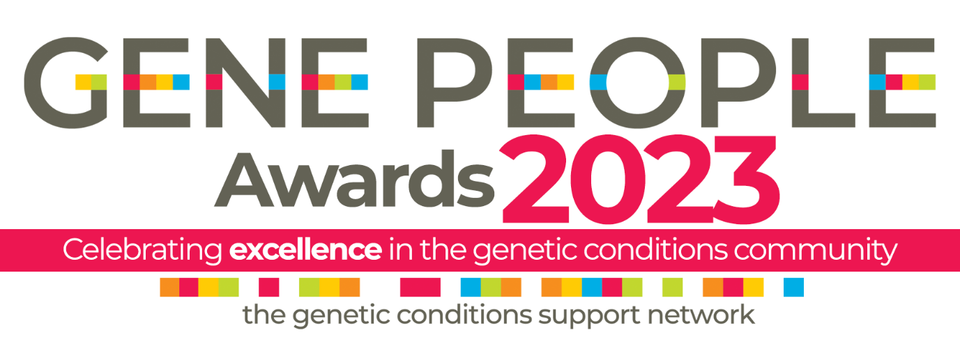
Nomination form
Thank you for your interest in nominating an individual, group or partnership for the Gene People Awards 2023! Please fill in this form with as much detail as possible to submit your nomination
The deadline for nominations is midday Thursday 2 November 2023.
Entries after the deadline, and entries that are incomplete, will not be considered.
Please email all completed forms to hello@genepeople.org.uk.

Your full name:

Your email address:

Your telephone number:

The name of the person you want to nominate:

Contact details of nominee:

How you know the nominee:

Nomination award category:

What did the nominee do that fits the criteria for the category? (No more than 250 words):

What was the outcome? (No more than 200 words):

How did the outcome benefit the genetics community? (No more than 200 words):

Is there anything else you would like to tell the judging panel about the nominee? (No more than 150 words):

